Input: The input for given code is in the format as shown:

Example : Enter the transitions of the following pda are:

First enter the number of states and number of transitions from the terminal.

Then enter your input as a file as shown in the given format.

d(a,1,Z)->(a,XZ)
d(a,1,X)->(a,XX)
d(a,0,X)->(b,X)
d(a,e,Z)->(a,e)
d(a,e,X)->(a,X)
d(b,1,X)->(b,e)
d(b,0,Z)->(a,Z)

Where a and Z are your initial state and initial stack symbol respectively.

e denotes epsilon i.e empty string.

The following convention is followed that all capital letters denote the stack symbols,small letters denote the states and numbers denote the input symbols.

Output: The output of the following program is as shown:

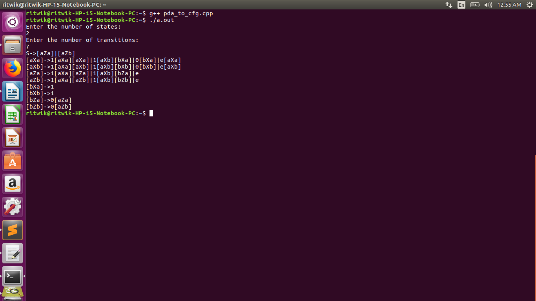
Here S is the starting state.

Code:

I have used a map to store the productions for each terminal symbol.

I have generated vector of vector of strings denoting the various production rules for the non-terminal. For this I had to use a recursive for loop which ran ‘n’ times with ‘m’ levels of recursion.

Here ‘n’ denotes the number of states and ‘m’ number of elements on top of stack for given transition of pda.

Ex: In the previous example number of states were 2 i.e ‘a’ and ‘b’ n=2
d(a,e,X)->(a,X)
For the above transition m=1

d(a,1,X)->(a,XZ)
Here m=2

So in my following template which I generate for the above transition will be filled with different values of states as shown:

[aX ‘x’] -> [aX ‘y’ ][ ‘y’Z ‘x’]

Here variable ‘x’ and ‘y’ denote the states of pda.

Here recur and recur2 generate the various permutations as mentioned above using for loop and recursion.

Recur is used for the case when u have number of elements on top of stack >= 0
Recur2 is used when u are popping elements from the stack or when u have ‘e’ as input symbol.

